Name- Rohan Nandi

**Week 1 Project**

**Topic**: Documenting each of the steps taken to create multiple tables in the Power BI.

**Step 1**:

For creating the table of the topic “Sustainable Supply Chain Performance Dashboard using Power BI”, firstly we need to download Power BI software in our desktop/laptop.

Fo that we need to click on the following link:

<https://www.microsoft.com/en-us/download/details.aspx?id=58494>

Once we click on the above mentioned link, we’ll be redirected to the following web page.

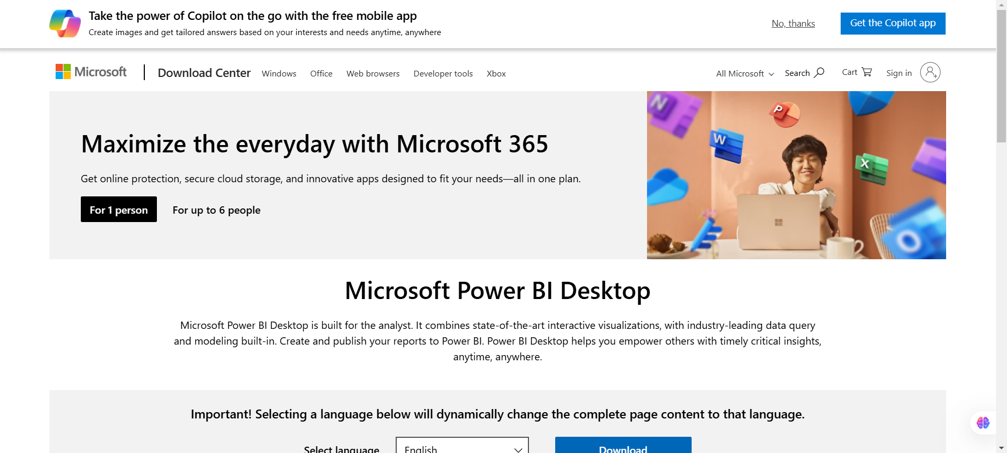

From there, we’ll download the required Poer BI software in our devices.

**Step 2:**

After downloading the Power BI, we need to launch it. So, after completing all the necessary things to be done for setting it up we’ll launch the Power BI software.

On opening it for the first time, we’ll be seeing the following screen infront of us.

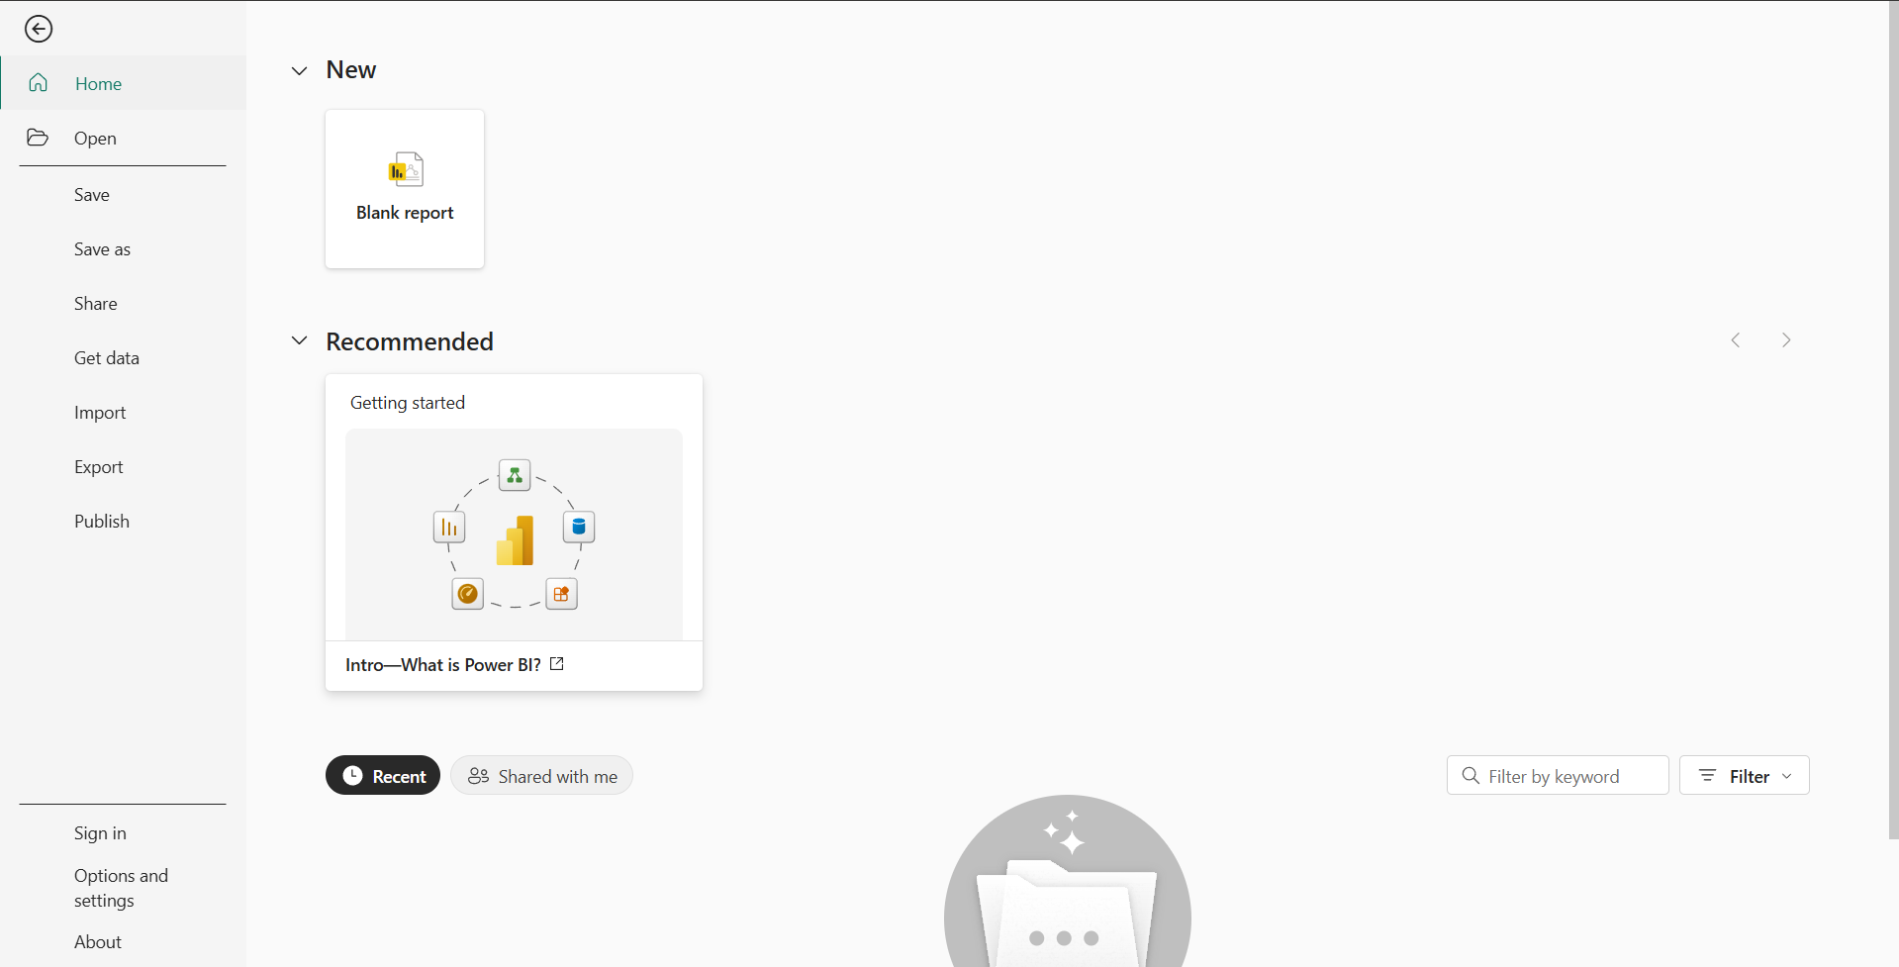

Here we need to click on the “Blank report” button situated in the upper-left corner, just under the “New” option.

**Step 3:**

After pressing on the “Blank report” button we’ll get to see the following type of screen.

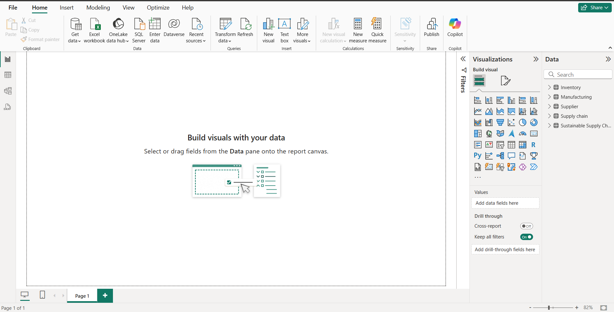

Here, the above shown window is known as the “Power BI Desktop Window”. On the right-hand side, we can also see multiple graphs which powered by AI. Just beside of that Visualization column, it’s the “Data” column where all the tables that have been done will be shown.



Here, the open box in the middle is known as “Canvas” where we all load our graphs.

**Step 4:**

For loading our data, we need to click on the “Get data” option which is situated in the upper-right corner and need to select the required type of file we’re using.

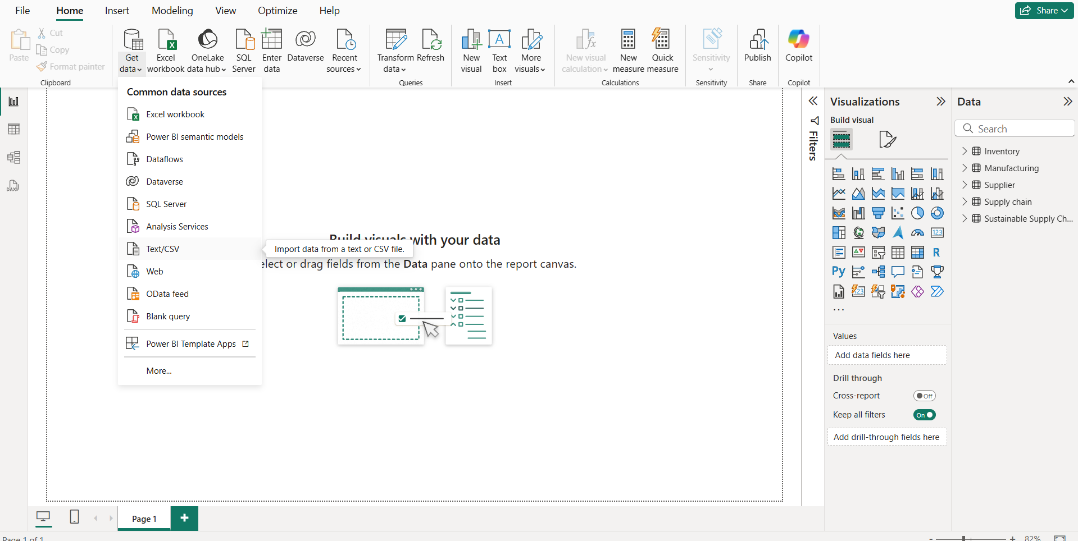

I’m selecting the **Text/CSV** file here because the table I am going to use is in csv format.

After selecting the csv file type in the “Get data” option, it’ll take time to load the details of the file. Once it done fetching the data in the file, It’ll the Table data in the “Data” column as we’ve discussed before.



The data column is shown with a red circle for better understanding.

**Step 5:**

After loading the data of the file named “Sustainable Supply Chain Performance.csv”, now we need to Transform the data for which we need to click on the “Transform data” button in the middle of the Home page.

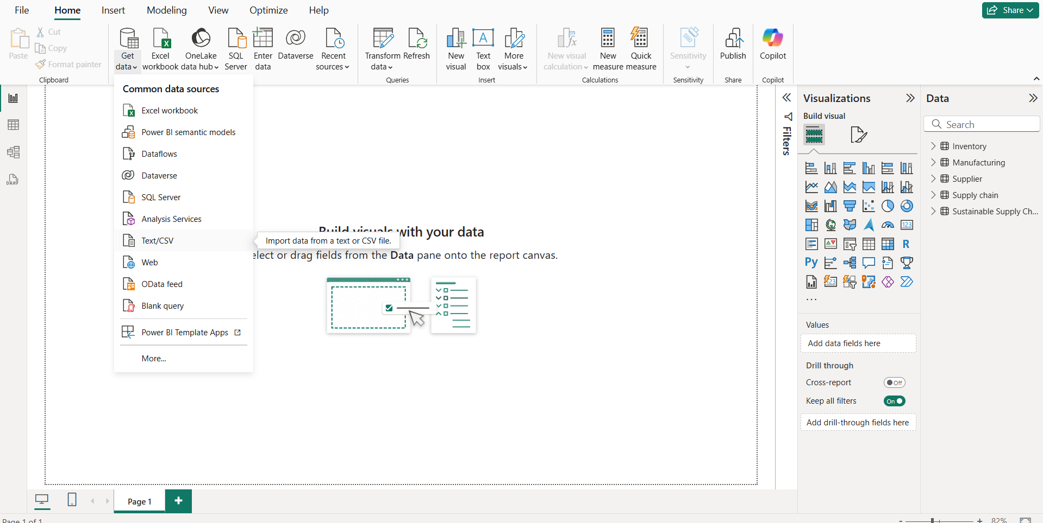



It’s been shown with a red circle for better understanding.

**Step 6:**

After clicking on the “Transform data” button, we’ll get to see the following type of screen infront of us.

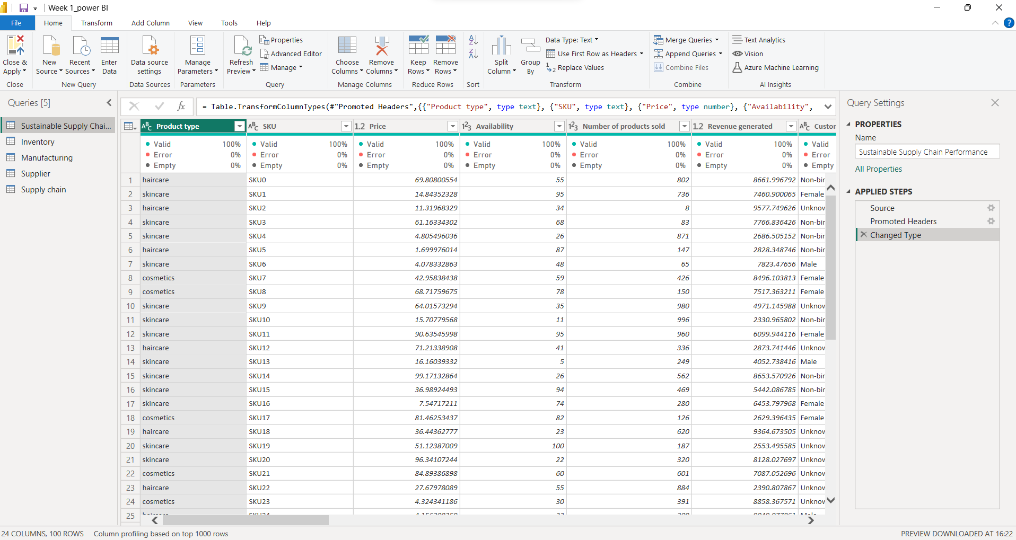  
This screen is known as “Power BI editor” where we’ll be doing all the necessary transformations of the data.

Now according to the Week-1 Project, we need to create 4 new tables out of the main table i.e., “Sustainable Supply Chain Performance”.

The 4 tables are as follows:

**Inventory Table:**

1. Product type

2. SKU

3. Availability

4. Number of products sold

5. Customer demographics

6. Stock levels

7. Lead times

8. Order quantities

9. Lead time

10. Revenue generated

**Manufacturing table:**

1. Product type

2. SKU

3. Production volumes

4. Manufacturing lead time

5. Manufacturing costs

6. Inspection results

7. ⁠ defect rates

**Supplier Table:**

1. Supplier name

2. Location

3. Lead time

4. transportation modes

5. Routes

**Supply chain table:**

1. Product type

2. SKU

3. Price

4. Availability

5. Number of products sold

6. Revenue generated

7. Customer demographics

8. Stock levels

9. Lead times

10. Order quantities

11. Shipping times

12. Shipping carriers

13. Shipping costs

14. Supplier name

15. Location

16. Lead time

17. Transportation modes

18. Routes

For doing so, we just need to right-click on the “Sustainable Supply Chain Performance” table and select the “duplicate” option to create a copy of the table in which we can modify the data according to our needs.

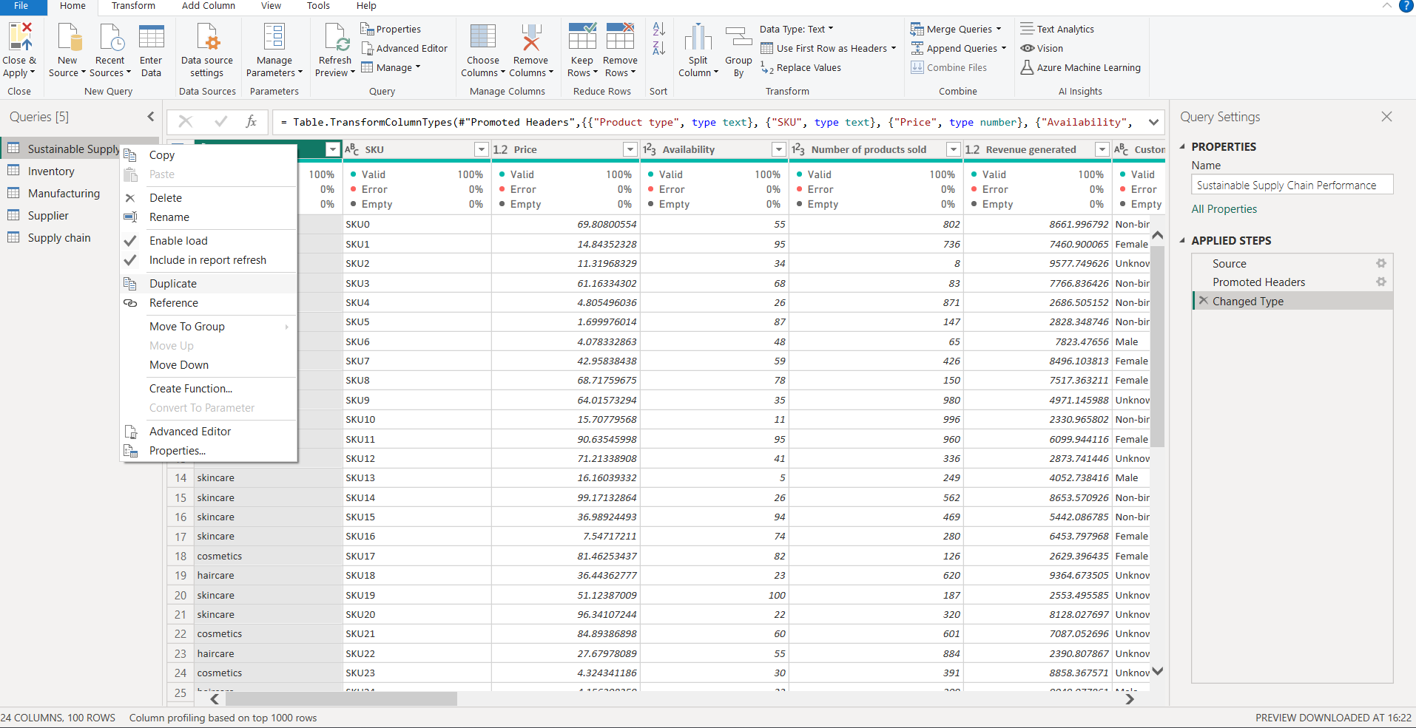



Then we need to match the data given in those 4 types of tables mentioned above with the data table given here and remove the unnecessary ones.

For ex- Suppose we’re Transforming the data of the table “**Supplier Table”. So,** firstlywe’ll check all those columns which are not required in the “**Supplier Table”.**

As we can see that

1. Supplier name

2. Location

3. Lead time

4. transportation modes

5. Routes

These columns are important for us to make the “Supplier Table”. So, we’ll simply delete all rest of the columns in the table to match our needs.

We can remove a column by right-clicking on that selected column and pressing “Remove” option.

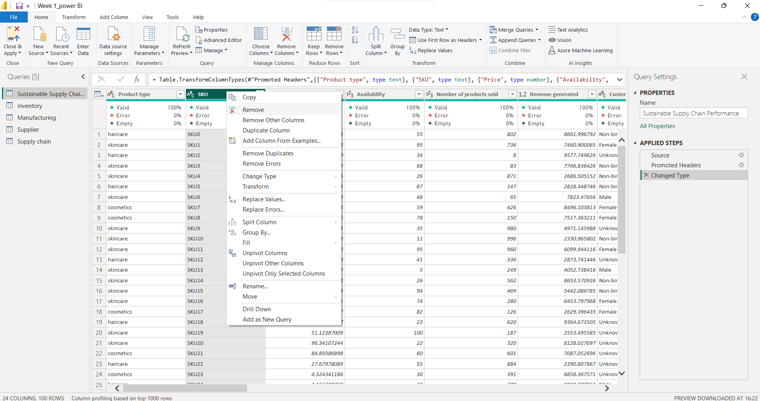



Or we can hold the “Ctrl” key and select more than one column to remove.

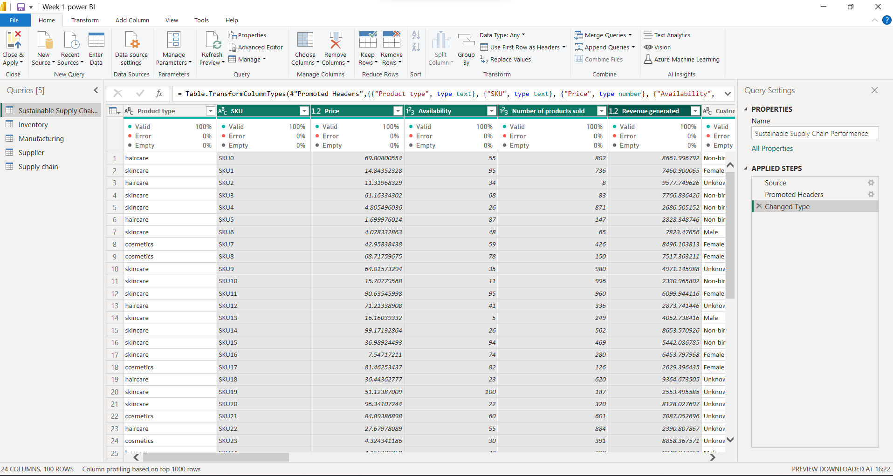

The selected columns are highlighted as green. After doing so we need to press the “Remove columns” option just above of the table in “File” page.

In the same way, we need to do the rest of the three tables i.e., **Inventory Table, Manufacturing table** and **Supply chain table.**

**Step 7:**

After transforming all the required tables, we need to save the changes and for that we need to click on the “Close & Apply” button situated in the top-left corner of the File page.

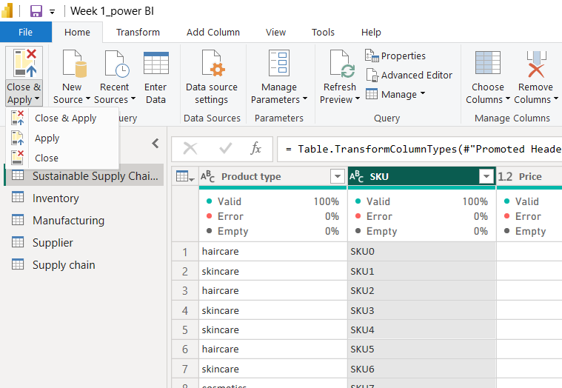



Just press on “Close & Apply bottom corner -> Close & Apply” option and save it.

After doing so, all the tables will be shown in the Data column of the “Power BI Desktop window”.

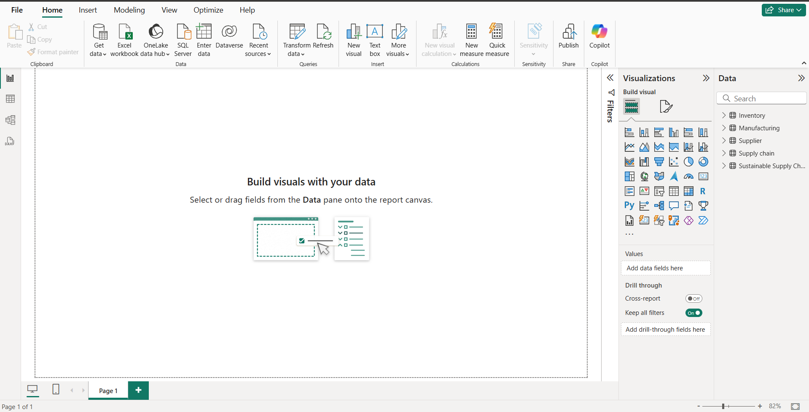



The tables are shown with a red bracket for better understanding.

Then just go to the “File” page and save the **Power BI** file in the devices.

Thank You!